GRUB ISSUE
There are two different GRUB shells. Depending on the root cause of the problem, you might find yourself at a GRUB shell prompt:
grub>

or at a GRUB rescue shell prompt:
grub rescue>

The following troubleshooting steps are related to the grub shell prompt:

The GRUB shell is a command-line interface that allows you to use a limited set of Linux commands. If you find yourself here instead of your usual login screen, it indicates that there is an issue with the boot process.
Before going to load the vmlinuz, one thing we need to clarify is whether the system is a manual partition or an LVM partition, because the kernel needs to load into the correct partition otherwise, it will not boot.
If the device name is different, it may be:
- /dev/vda2 (if KVM/cloud)
- /dev/sda2 (normal server)
A very important thing while doing manually booting:
Never assume /dev/sda. Always match actual disk type:
- SATA → sda
- VirtIO → vda
- NVMe → nvme0n1pX
In my case, it’s an “sda”.
If it is a Manual partition, follow the steps below:
At the grub screen:

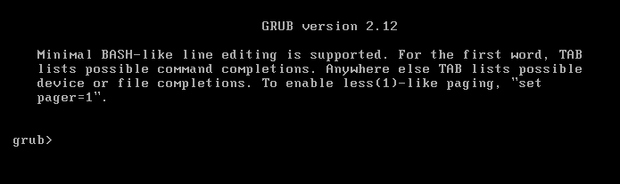

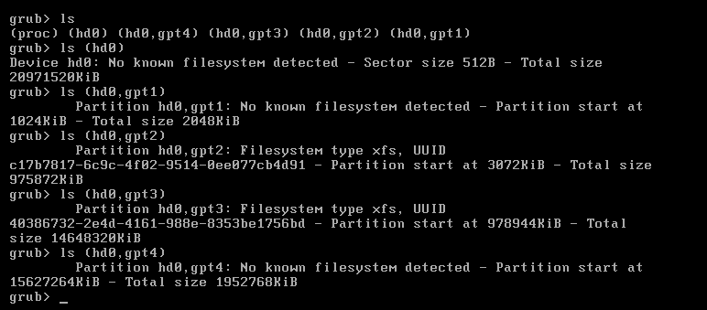

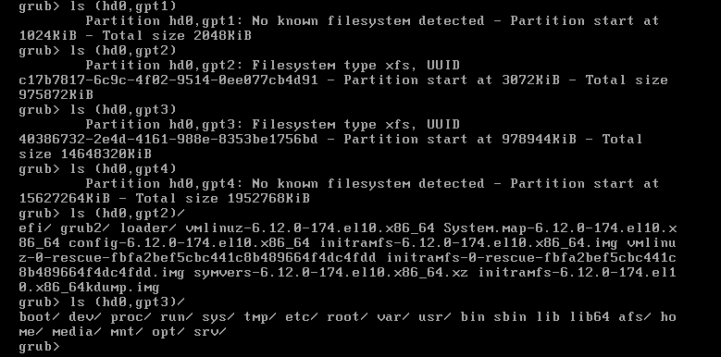

From the GRUB view, the disk is (hd0). Usually, that maps to /dev/sda.
If It Fails With “cannot find root device”. Then that system is using LVM.
(hd0) is the first hard drive.
(hd0,gpt1) → small 2MB → likely BIOS boot partition

(hd0,gpt2) → XFS → contains /boot, vmlinuz, initramfs

(hd0,gpt3) → XFS → contains /boot /dev /proc /run /sys /tmp /etc /root /var /usr ... → This is root filesystem

(hd0,gpt4) → no filesystem → possibly swap

From the output:

(hd0,gpt3) → contains /etc /usr /var

This is the root ( / ) partition.

(hd0,gpt2) → contains vmlinuz + initramfs

Partition | Purpose
gpt1 | BIOS boot
gpt2 | /boot
gpt3 | /
gpt4 | swap

Set root to /boot partition:

- set root=(hd0,gpt2)

Load kernel type (press TAB to autocomplete):

- linux /vmlinuz-6.12.0-174.el10.x86_64 root=/dev/sda3 ro

Important:
The root partition is gpt3 → so /dev/sda3

Load initramfs:

- initrd /initramfs-6.12.0-174.el10.x86_64.img

Boot:

- boot

If it Boots Successfully. Then inside the OS:

- sudo grub2-install /dev/sda

- sudo grub2-mkconfig -o /boot/grub2/grub.cfg

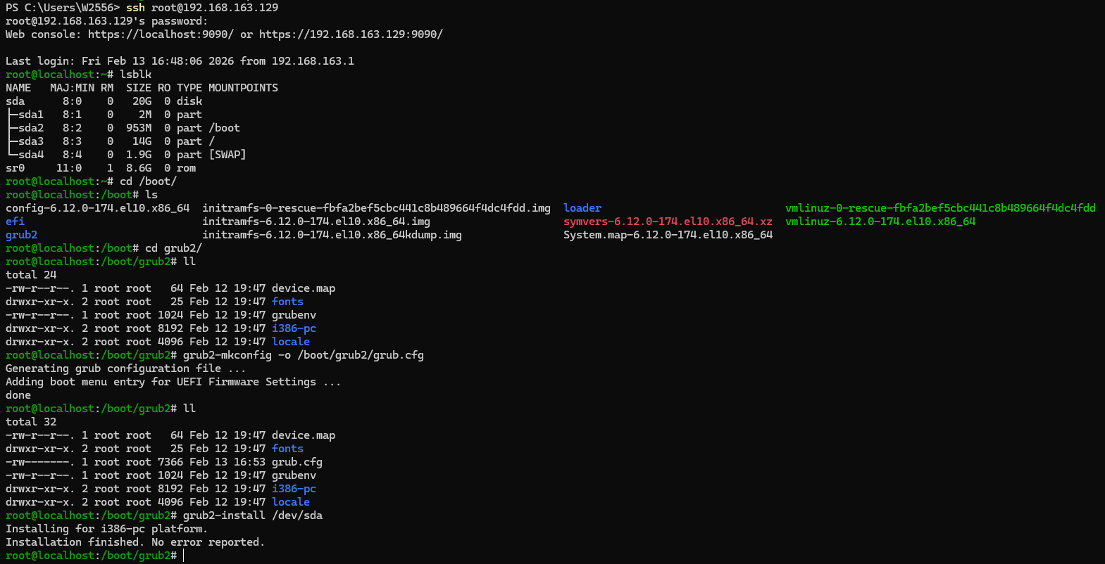

For UEFI systems:

- sudo grub2-mkconfig -o /boot/efi/EFI/*/grub.cfg

OR
If it is an LVM partition, follow the steps below:

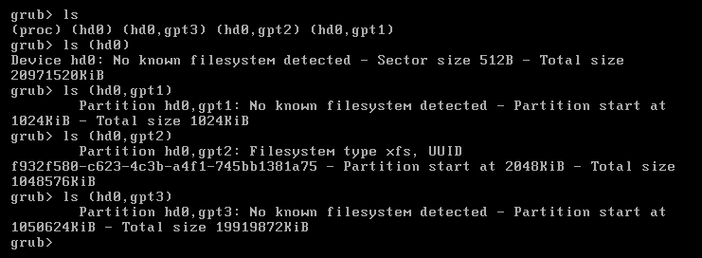
Hard Disk Details:
- (hd0,gpt1) → No known filesystem (probably EFI partition or BIOS boot)
- (hd0,gpt2) → Filesystem type xfs, UUID shown
- (hd0,gpt3) → No known filesystem (maybe swap or LVM physical volume)
That actual Linux root partition is located in (hd0,gpt2).
Now recover it manually:
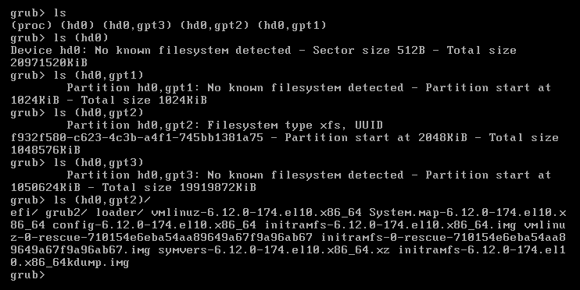
Here in (hd0,gpt2)/ it displays the EFI, GRUB2, vmlinuz, initramfs, and more. This is the /boot directory, as it contains all boot-related files.
Now GRUB wants to know where the root is:
- set root=(hd0,gpt2)
In my case the root filesystem is probably on gpt3, not gpt2.
Because:
- gpt2 = boot partition (small, ~1GB)
- gpt3 = large partition (likely root LVM or root FS)
At the grub screen:
- set root=(hd0,gpt2)
- linux (hd0,gpt2)/vmlinuz-6.12.0-174.el10.x86_64 root= /dev/mapper/<VGNAME>-root ro
- initrd (hd0,gpt2)/initramfs-6.12.0-174.el10.x86_64.img
- boot

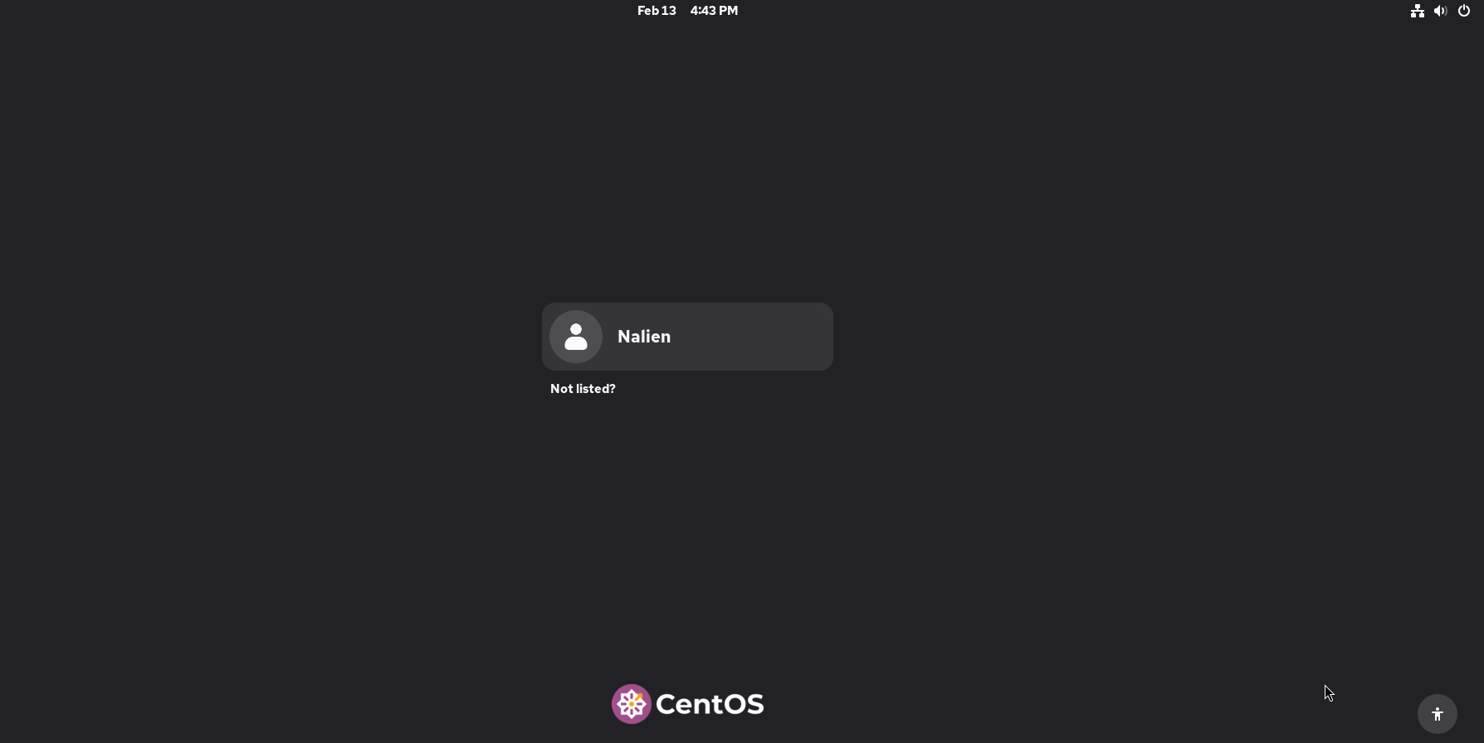
After the system successfully Boots run the following commands:
We must fix GRUB permanently so you don’t land in this situation again.
- grub2-mkconfig -o /boot/grub2/grub.cfg
If a UEFI system:
- grub2-mkconfig -o /boot/efi/EFI/*/grub.cfg
In my case, it’s an “nvme0n1”.
Then reinstall the bootloader:
- grub2-install /dev/nvme0n1
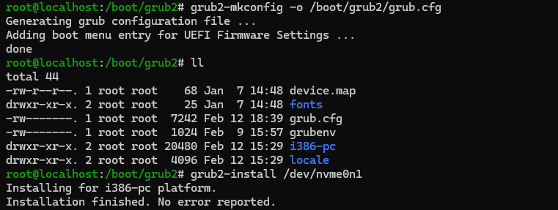

The following troubleshooting steps are related to the grub rescue shell prompt:
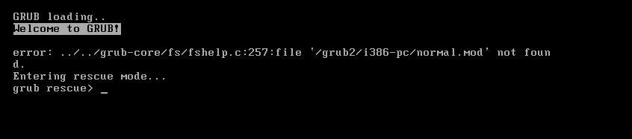
This is a GRUB corruption / broken bootloader problem.
The key error is:
file '/grub2/i386-pc/normal.mod' not found
Entering rescue mode...
grub rescue>
That means:
GRUB is installed, but it cannot find its modules. Either /boot is corrupted, or a wrong disk/partition is being loaded, or GRUB was partially overwritten.
This is not a simple issue, but it’s fixable.
Type the ls command and find how many hard disks and partitions are there.
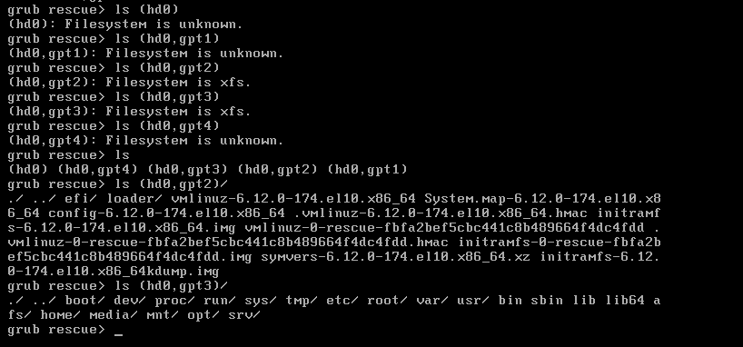
(hd0,gpt2) → contains /efi, /loader, kernel images → this is /boot partition
(hd0,gpt3) → contains /boot /dev /etc /usr ... → this is root ( / ) partition
Set Correct Root and Prefix:
If doesn’t know, just type the “set” command in the terminal output will show the correct root and prefix details. In my case
(hd0,gpt2) → contains vmlinuz and initramfs
So do this carefully:
- set root=(hd0,gpt2)
- set prefix=(hd0,gpt2)/grub2
- insmod normal
- normal
If insmod normal works → it will bring back the normal GRUB menu.
If insmod normal Fails proceed with the following steps to resolve the issue:
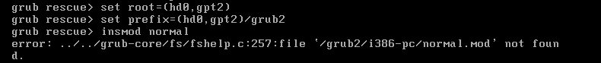
The error:
file '/grub2/i386-pc/normal.mod' not found
This tells us something very important:
The GRUB is BIOS (i386-pc version). The grub modules are missing or corrupted. This is not a small config issue. The GRUB core image cannot find its modules. Manual loading will NOT work anymore.
What Actually Happened:
The GRUB core (installed in MBR/BIOS area) is looking for: /boot/grub2/i386-pc/normal.mod
But either:
/boot/grub2/i386-pc/ is missing or modules are damaged or grub2 package partially removed or disk corruption happened
Since (hd0,gpt2) clearly contains /boot, but GRUB cannot load modules → reinstall is required.
Step 1 — Boot from CentOS ISO
Choose:
Troubleshooting → Rescue a CentOS system
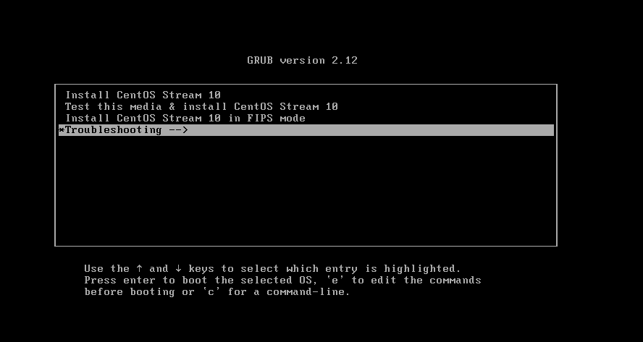
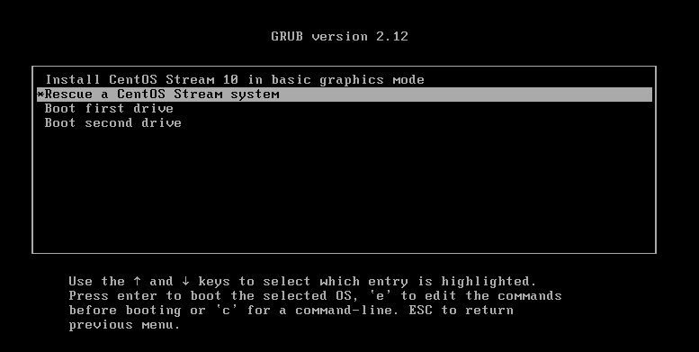
Step 2 — Enter Chroot
After it mounts your system:
- chroot /mnt/sysimage
Now inside your installed system.
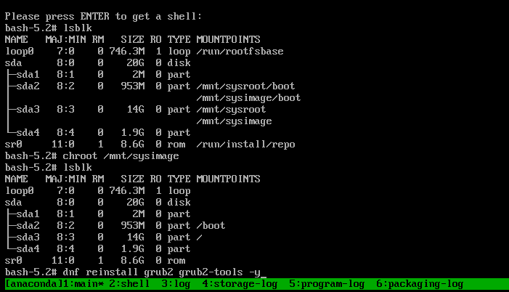
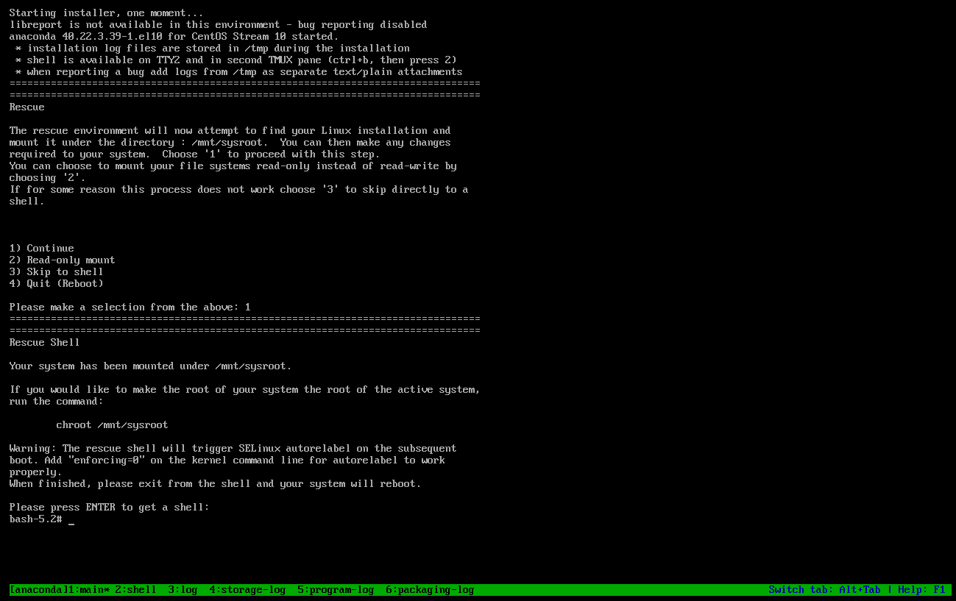

Step 3 — Reinstall GRUB (BIOS Mode)
Since the error shows i386-pc, this is BIOS mode.
Run:
- dnf reinstall grub2 grub2-tools -y
- grub2-install /dev/sda
- grub2-mkconfig -o /boot/grub2/grub.cfg
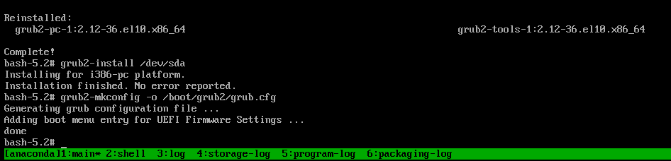
Exit and Reboot
- exit
- reboot
Remove ISO.
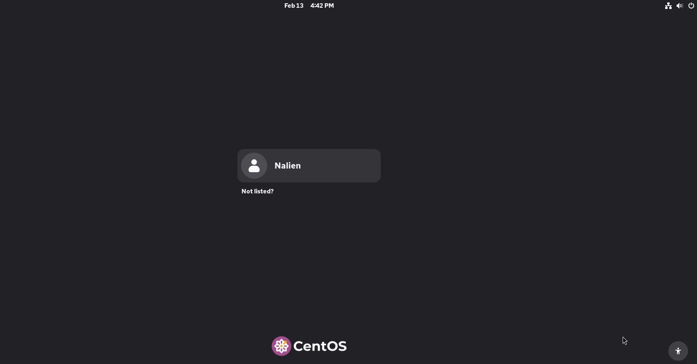

How to find if it's a sda. vda or nvme in grub screen?
When in GRUB, Linux device names like /dev/sda, /dev/vda, /dev/nvme0n1 do NOT exist yet. GRUB has its own naming system:
(hd0)
(hd0,gpt1)
(hd0,gpt2)
So cannot directly “see sda or nvme” inside GRUB.
But can determine it logically.
Method 1 — Check from Kernel Boot Messages (Most Reliable):
After loading the kernel and it starts printing logs, look carefully at the disk detection lines.
Examples:
If SATA / SCSI
You will see:
sd 0:0:0:0: [sda] ...
→ That means /dev/sda

If VirtIO (KVM)
You will see:
vda: vda1 vda2
→ That means /dev/vda

If NVMe
You will see:
nvme0n1: p1 p2 p3

Method 2 — Use GRUB UUID
Inside GRUB, you saw:
Filesystem type xfs, UUID f932f580-....
Later in the emergency shell:
- ls /dev/disk/by-uuid/
So, you map UUID → device name.

Method 3 — Use Rescue Mode
Boot from ISO → rescue mode.
Then run:
- lsblk -f
That shows real device names cleanly.
Important Concept
GRUB disk names:
GRUB | LINUX NAME
(hd0) | First disk
(hd0,gpt1) | First disk p1
(hd0,gpt2) | First disk p2

But whether that disk becomes: /dev/sda, /dev/vda, /dev/nvme0n1
Depends on the hardware type, the hypervisor, Driver loaded by the kernel
GRUB does not care about Linux naming.
Best Practice When Manually Booting:
Instead of guessing use UUID (safest method):
Inside GRUB:
- linux ... root=UUID=<your-root-uuid> ro
Example:
- linux (hd0,gpt2)/vmlinuz-... root=UUID=xxxx-xxxx ro
Cannot directly see sda/vda/nvme inside GRUB.
- Watching kernel boot logs
- Checking UUID mapping
- Using rescue environment

